Home
Vision: To revolutionize healthcare delivery in Tanzania and beyond by making quality, accessible, and affordable healthcare available to everyone through innovative, technology-driven, and environmentally sustainable solutions.

500,000+ Patients Served
50+ Communities Benefited
24/7 Access to Digital Healthcare

75%
Limited Access to Healthcare
Many people still travel long distances to reach essential medical services.
60%+
Preventable Diseases
Can be managed through early detection and timely treatment.
Millions
People Need Better Healthcare Access
Digital health solutions are transforming how care is delivered across Tanzania.

AGKI delivers integrated healthcare through solar-powered mobile clinics and an AI-powered digital health platform that connects patients with doctors, laboratories, pharmacies, and hospitals for appointments, diagnostics, telemedicine, digital prescriptions, and medication access. To date, we have helped over 500,000 people access quality healthcare services. Our diversified revenue model—including pay-per-service, subscriptions, and strategic partnerships—ensures long-term sustainability and scalable impact.

problem
Inadequate Infrastructure and Supply Chains
Many clinics and hospitals, particularly in rural areas, operate without beds, reliable electricity, running water, or basic surgical facilities. This is compounded by weak supply chains, resulting in chronic shortages of essential medications, vaccines, and diagnostic equipment.

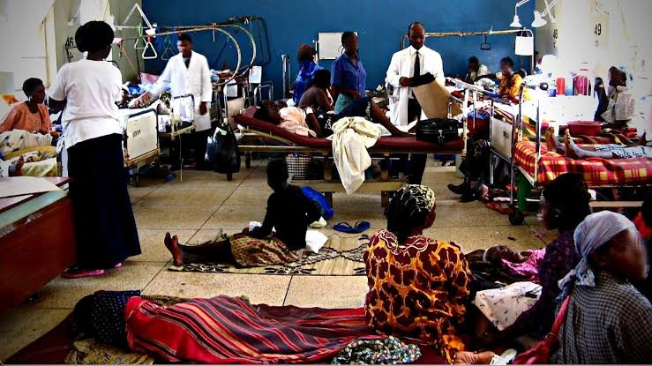
.

. Critical Shortage of Healthcare Workers
Sub-Saharan Africa bears over 20% of the global disease burden but houses only a tiny fraction of the world's healthcare workforce. The region faces a severe shortage of doctors, nurses, and midwives due to limited training capacity and "brain drain" where trained professionals emigrate to wealthier nations for better pay and working conditions.


High Out-of-Pocket Costs & Lack of Funding
Most countries in the region lack comprehensive health insurance systems. As a result, patients must pay directly for medical care, leading to extreme financial hardship or causing families to skip lifesaving treatment entirely due to cost.

SOLUTION
AGKI delivers integrated healthcare through solar-powered mobile clinics and an AI-powered digital health platform that connects patients with doctors, laboratories, pharmacies, and hospitals for appointments, diagnostics, telemedicine, digital prescriptions, and medication access. To date, we have helped over 500,000 people access quality healthcare services. Our diversified revenue model including pay-per-service, subscriptions, and strategic partnerships ensures long-term sustainability and scalable impact.

